How to Register for Classes!

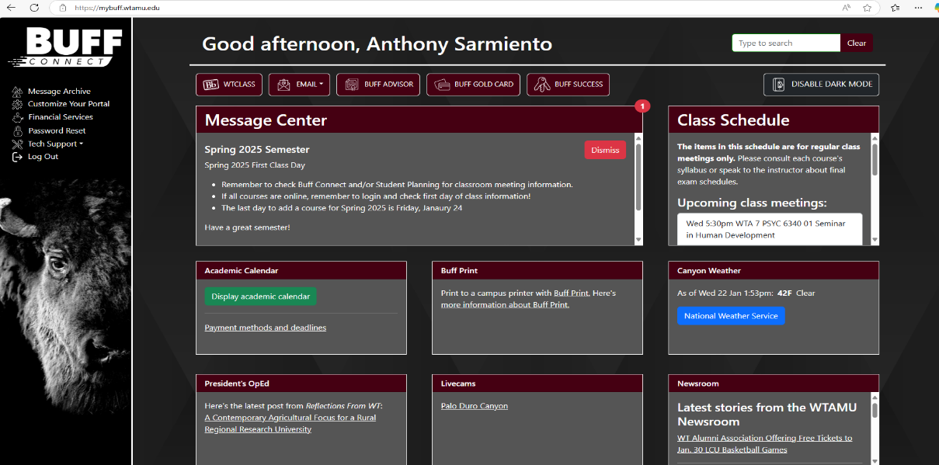
1.)

Log into
Buff Portal

on
www.wtamu.ed
u

2.)

Once you log in,
select

Buff Advisor
link as shown.

3.) In Buff Advisor, on the left hand menu select Student Planning
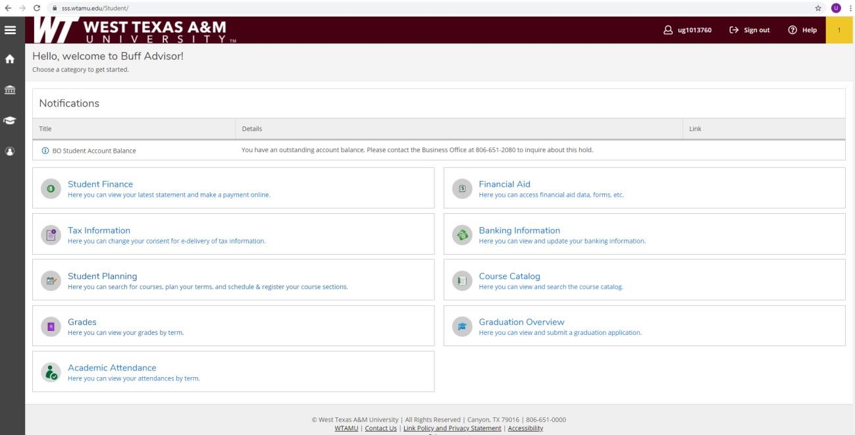

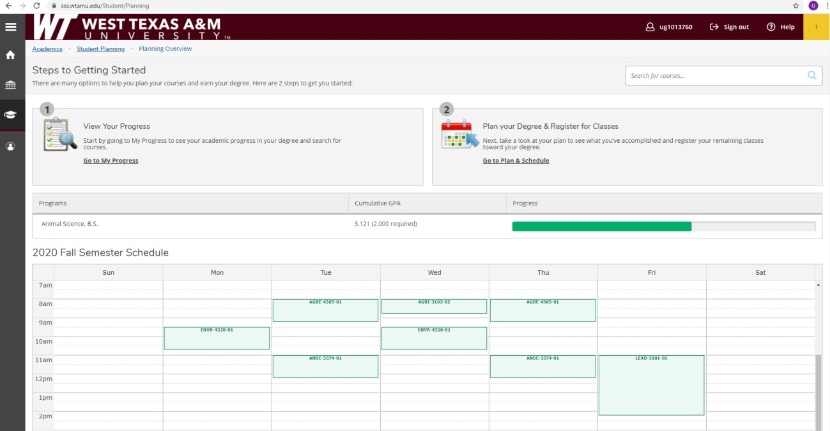
4.)

Then select
;

“Go to plan and Schedule”.

5.) Use the arrows next to the semester to get to 2021 spring semester. You will need to make sure sections are selected for all courses planned. When your registration block opens, the “Register Now” button will activate and turn blue. It is important to use the “Register Now” button instead of registering class by class. After you select “Register Now” all planned courses will be green and you will be registered for the spring!
